ITDs to transposed tones

(Bernstein & Trahiotis, 2002)

Sinusoid ½-wave rectified and all components > 2 kHz removed, then transformed back to time and used to modulate a high-frequency carrier

For the high-frequency stimuli, a continuous diotic noise low-pass filtered at 1300 Hz (No equivalent to 30 dB SPL) was presented to preclude the listeners’ use of any information at low spectral frequencies

4 300-ms observation intervals separated by 400 ms. 1st and 4th intervals diotic (ITD = 0) 2nd or 3rd interval has left-leading ITD

At 128 Hz, threshold ITD ≈ 100 μs but note that 4 NH adults who ‘received substantial practice before formal collection of data’. Note too that low frequency thresholds (near the 40 Hz of Bharadwaj) is not much different from 128 Hz.

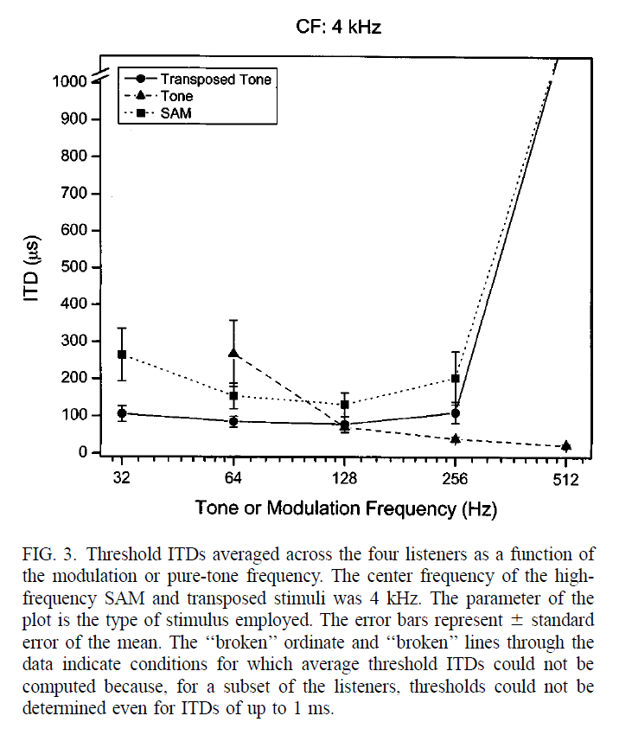

(Dreyer & Oxenham, 2008)

The transposed tones were generated by multiplying a 4 kHz sinusoid with a 125 Hz sinusoid that had been half-wave rectified and lowpass filtered (Butterworth fourth order) at 800 Hz (0.2 times the carrier frequency). Presented in a noise which contained a stop-band between 0.9 and 1.1 fc (3600–4400 Hz). 4 NH listeners. Training for each subject lasted between 4 and 6 h. Listener decided whether the right ear led in the first or second presentation of 2I-2AFC with symmetric ITDs (+ and –). ITDs here are the total change, so with half in each interval.

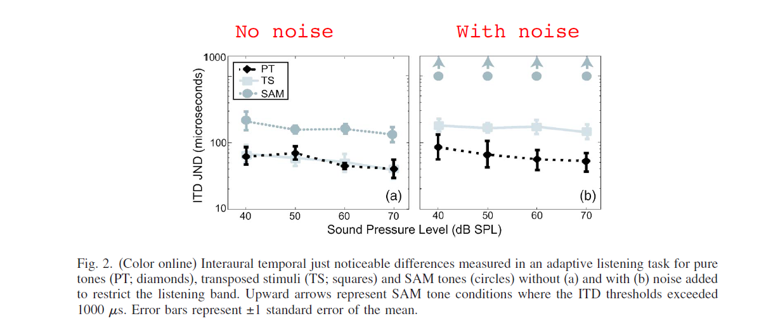

Transposed tones have ITD thresholds < 100 μs in quiet. ≈ 200 μs with noise.

(Ochi, Yamasoba, & Furukawa, 2014, 2016)

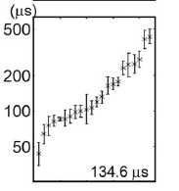Similar stimuli to Bernstein & Trahiotis (2002), so no notched-noise. 2014 study has 22 young NH adults. 2016 has older NH & HI. Symmetric changes in a 2I-1AFC task. Thresholds ~ 135 μs (50 – 500 μs). No differences in older listeners. Even HI older listeners didn’t do that badly.

Young NH at left. ITDs for transposed tones. 3 groups at right: Young, Elderly; NH, HI

Bernstein, L. R., & Trahiotis, C. (2002). Enhancing sensitivity to interaural delays at high frequencies by using “transposed stimuli”. *The Journal of the Acoustical Society of America, 112*(3), 1026. doi:10.1121/1.1497620

Dreyer, A. A., & Oxenham, A. J. (2008). Effects of level and background noise on interaural time difference discrimination for transposed stimuli. *Journal of the Acoustical Society of America, 123*(1), EL1-EL7. doi:10.1121/1.2820442

Ochi, A., Yamasoba, T., & Furukawa, S. (2014). Factors that account for inter-individual variability of lateralization performance revealed by correlations of performance among multiple psychoacoustical tasks. *Front Neurosci, 8*, 27. doi:10.3389/fnins.2014.00027

Ochi, A., Yamasoba, T., & Furukawa, S. (2016). Contributions of Coding Efficiency of Temporal-Structure and Level Information to Lateralization Performance in Young and Early-Elderly Listeners. In P. VanDijk, D. Baskent, E. Gaudrain, E. DeKleine, A. Wagner, & C. Lanting (Eds.), *Physiology, Psychoacoustics and Cognition in Normal and Impaired Hearing* (Vol. 894, pp. 19-28).